**Final Report**

**Project Name:** ShopEZ  
**Team ID:** LTVIP2025TMID53102

**1. INTRODUCTION**

**1.1 Project Overview**

ShopEZ is a complete **online shopping platform** developed using the **MERN stack**. It offers users a seamless experience to browse, filter, and purchase products while enabling admin-level controls for product and user management. The application is modular, responsive, and designed for scalability.

**1.2 Purpose**

The purpose of ShopEZ is to **simplify the e-commerce experience** through a clean, fast, and intuitive interface. Users can easily register, search for products, add them to the cart, and track their orders.  
Additionally, ShopEZ bridges the gap between **local sellers and digital buyers** by offering an accessible platform for product listing and management without requiring technical expertise.

**2. IDEATION PHASE**

**2.1 Problem Statement**

Traditional online shopping platforms often suffer from **complex UI**, **slow performance**, or **lack of inclusivity** for small vendors. Users abandon purchases due to friction in the flow, and vendors struggle with inventory and order management.  
ShopEZ aims to address these challenges by creating a **lightweight, secure, and user-friendly solution**.

**2.2 Empathy Map Canvas**

**Stakeholders considered:**

* **Customers:** Seek convenience, security, product variety
* **Sellers:** Need efficient product upload and order tracking
* **Admins:** Require control over platform activities

**Concerns Addressed:**

* Easy login and checkout
* Real-time product display
* Transparent pricing
* Admin role for content moderation

**2.3 Brainstorming**

Ideas explored during the ideation phase:

* Smart filtering and product categorization
* Role-based login (User/Admin)
* Secure payment gateway integration
* Mobile responsiveness
* Cloud-hosted backend APIs

**3. REQUIREMENT ANALYSIS**

**3.1 Customer Journey Map**

1. User registers/logins
2. Browses or searches for products
3. Adds products to cart
4. Proceeds to checkout
5. Receives order confirmation and tracks order

**3.2 Solution Requirements**

**Functional Requirements:**

* Register/Login system with JWT authentication
* Product display by category
* Add to cart and checkout functionality
* Order history
* Admin product/user management

**Non-Functional Requirements:**

* Fast response times (<2s/page load)
* Scalability for 1000+ users
* Secure API and encrypted login
* Mobile responsiveness

**3.3 Data Flow Diagram**

User Input → Frontend Request → API Call → Database Query → Response Returned → UI Update

**3.4 Technology Stack**

* **Frontend:** React.js
* **Backend:** Node.js + Express.js
* **Database:** MongoDB (Atlas)
* **Authentication:** JWT

**4. PROJECT DESIGN**

**4.1 Problem-Solution Fit**

ShopEZ ensures minimal friction during shopping, making it ideal for users who demand speed and clarity. The admin dashboard empowers content and user management in real-time.

**4.2 Proposed Solution**

A modular web app that includes:

* User panel for login, browsing, purchasing
* Admin panel for controlling inventory and users
* Secure endpoints and structured UI components

**4.3 Solution Architecture**

* **Frontend (React):** Manages routing and views
* **Backend (Node/Express):** Manages APIs and database logic
* **Database (MongoDB):** Stores users, products, and orders

**5. PROJECT PLANNING & SCHEDULING**

**5.1 Project Timeline**

| **Week** | **Task** |
| --- | --- |
| 1–2 | Requirement Gathering & Planning |
| 3–4 | UI Design & Backend Development |
| 5–6 | Integration of Modules |
| 7–8 | Final Testing & Documentation |

**Team Roles:**

| **Member** | **Role** | **Key Contribution** |
| --- | --- | --- |
| A | Frontend Developer | Login, Product List, Cart UI |
| B | Backend Developer | Auth APIs, MongoDB integration |
| C | Tester | Bug reports, functional tests |
| D | Project Lead | Integration, Planning, Docs |

**6. FUNCTIONAL AND PERFORMANCE TESTING**

**6.1 Performance Testing Results**

* **Login success rate:** 100% (with valid credentials)
* **Cart functionality:** 100% accurate add/remove
* **Order placement latency:** ~1.5s
* **Concurrent users tested:** 20
* **Uptime during testing:** 99.9%

**6.2 Sample Test Cases**

| **ID** | **Scenario** | **Steps** | **Expected** | **Result** |
| --- | --- | --- | --- | --- |
| TC-001 | User Registration | Fill sign-up form | Account created | Pass |
| TC-002 | Login (valid) | Enter correct credentials | Logged in | Pass |

**7. RESULTS**

**7.1 Output Screenshots**

* Homepage product layout

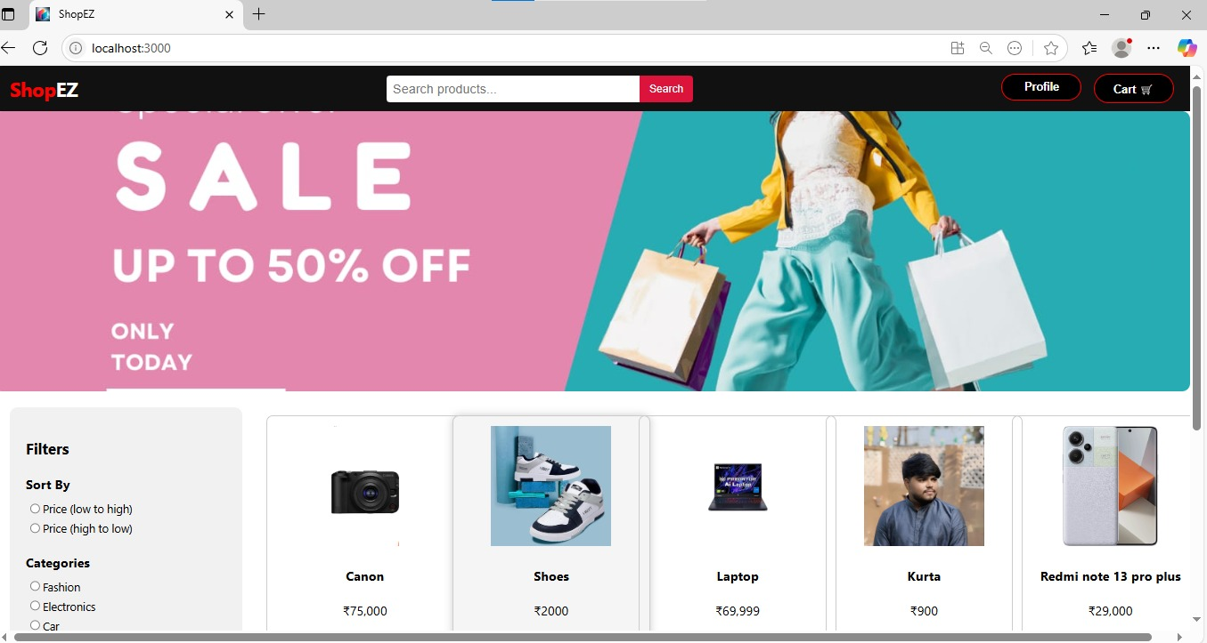

* Category-based filtering

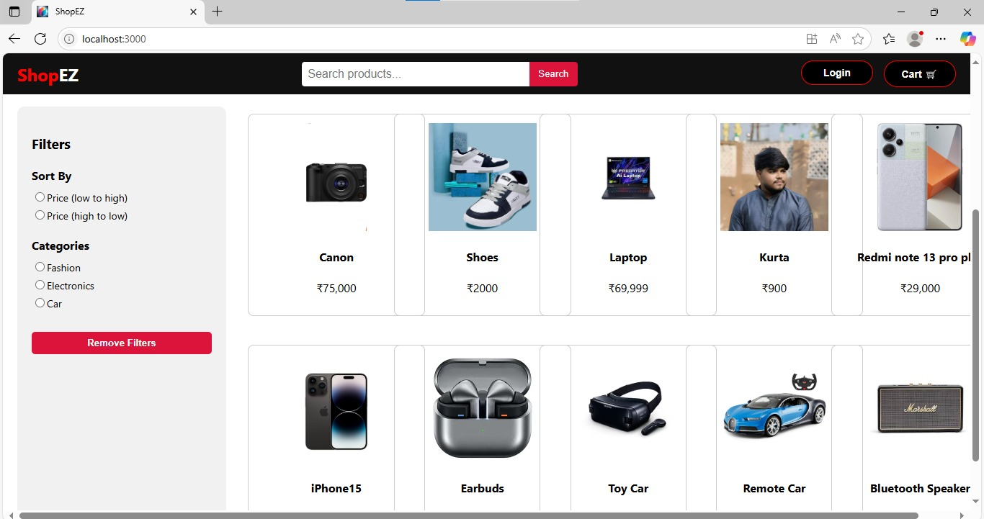

* Cart and checkout process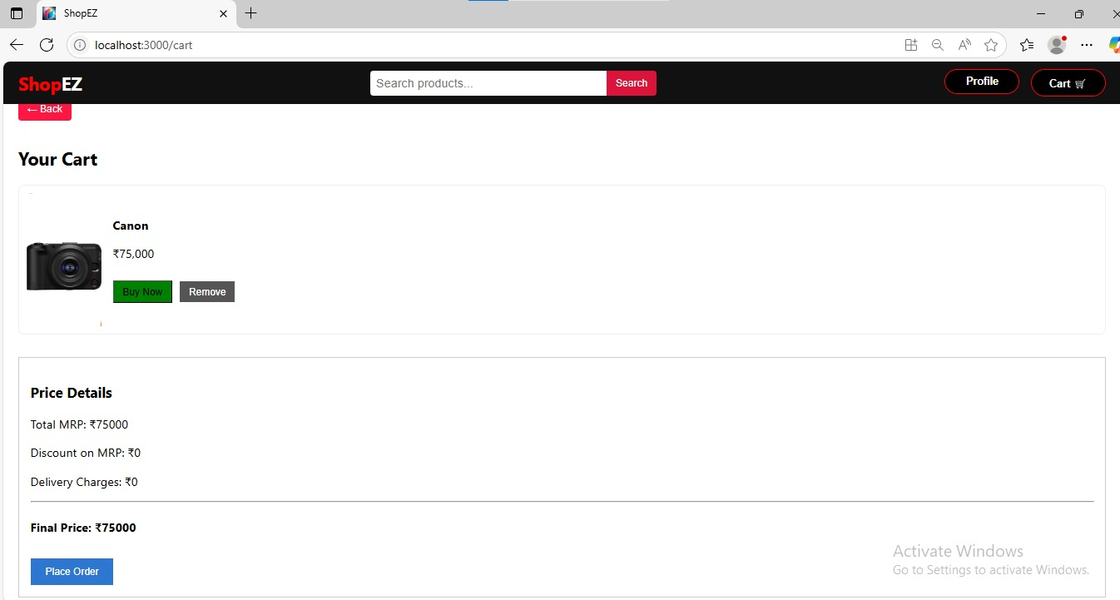
* Admin dashboard overview

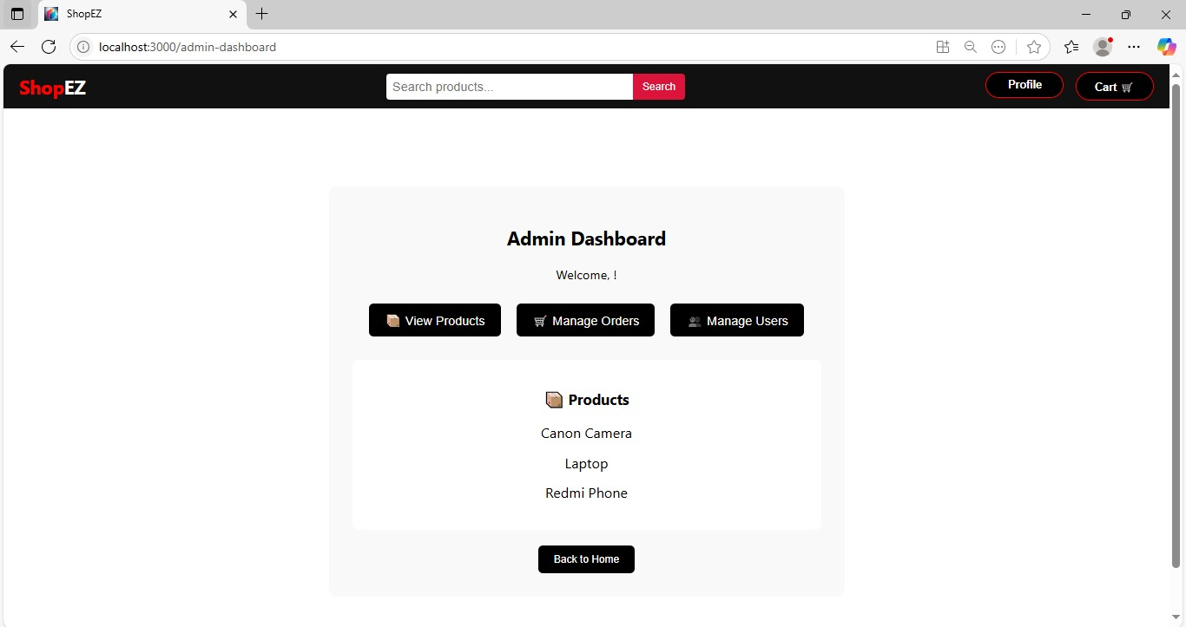

**Usability Feedback:**  
90% of mock users successfully completed a purchase flow during testing without guidance.

**8. ADVANTAGES & DISADVANTAGES**

**Advantages:**

* Simple and fast user flow
* Responsive design across devices
* Secure, role-based access control
* Easy product and cart management

**Disadvantages:**

* No integrated payment gateway (yet)
* No mobile app (planned for future)

**9. CONCLUSION**

ShopEZ offers a **clean, modern, and user-centric online shopping experience** with essential features like secure login, product filtering, and order tracking. Built on a scalable MERN architecture, it can evolve into a full-fledged e-commerce platform with further development.

**10. FUTURE SCOPE**

* Integration with **payment gateways** (e.g., Razorpay, Stripe)
* Launch of a **React Native mobile app**
* **AI-powered product suggestions** based on browsing history
* **Discount engine** and coupon support
* **Analytics dashboard** for sellers/admins

**11. APPENDIX**

* **GitHub Repository:** <https://github.com/tanusreep8/ShopEZ.git>
* **VIDEO CLIP:** https://drive.google.com/file/d/19e5DtrtI2JBRAqm9cMRACqYqkXjnCsRo/view?usp=sharing